Navigation and Control of an Unmanned Surface Vessel

Mechatronics Project 488

Final Report

Luke Kingwill 20725728

Supervisor: Prof J. Versfeld

2022

Plagiarism declaration

I have read and understand the Stellenbosch University Policy on Plagiarism and the definitions of plagiarism and self-plagiarism contained in the Policy [Plagiarism: The use of the ideas or material of others without acknowledgement, or the re-use of one's own previously evaluated or published material without acknowledgement or indication thereof (self-plagiarism or text-recycling)].

I also understand that direct translations are plagiarism, unless accompanied by an appropriate acknowledgement of the source. I also know that verbatim copy that has not been explicitly indicated as such, is plagiarism.

I know that plagiarism is a punishable offence and may be referred to the University's Central Disciplinary Committee (CDC) who has the authority to expel me for such an offence.

I know that plagiarism is harmful for the academic environment and that it has a negative impact on any profession.

Accordingly all quotations and contributions from any source whatsoever (including the internet) have been cited fully (acknowledged); further, all verbatim copies have been expressly indicated as such (e.g. through quotation marks) and the sources are cited fully.

I declare that, except where a source has been cited, the work contained in this assignment is my own work and that I have not previously (in its entirety or in part) submitted it for grading in this module/assignment or another module/assignment.

I declare that have not allowed, and will not allow, anyone to use my work (in paper, graphics, electronic, verbal or any other format) with the intention of passing it off as his/her own work.

I know that a mark of zero may be awarded to assignments with plagiarism and also that no opportunity be given to submit an improved assignment.

Signature:

Name: Student no:

Date:

Abstract

Note that in Mechanical Project and in Mechatronic Project, this abstract is replaced by the prescribed executive summary table.

Acknowledgements

D

Table of contents

**Page**

Plagiarism declaration i

Abstract ii

Acknowledgements iii

List of figures v

List of tables vi

List of symbols vii

1 Introduction 1

1.1 Background 1

1.2 Objectives 1

1.3 Motivation 1

2 Literature review 2

2.1 GPS 2

2.1.1 History of GPS 2

2.1.2 Modern GPS 3

2.1.3 How GPS Works 4

2.2 Digital Compass 4

2.2.1 What is Magnetic North 4

2.3 Localization Method 5

2.3.1 Kalman Filter 5

3 Content chapter 6

3.1 Heading level 2 6

3.1.1 Heading level 3 6

4 Conclusions 9

5 References 10

List of figures

**Page**

Figure 1: Water plants 8

List of tables

**Page**

Table 1: Acceptable page layouts 2

List of symbols

*A* Wing area

*c* Chord length

** Angle of attack

# Introduction

## Background

Starting from the big picture, gradually narrow focus down to this project and where this report fits in.

## Objectives

The objectives of the project (in some cases the objectives of the report). If necessary describe limitations to the scope.

## Motivation

Why this specific project/report is worthwhile.

# Literature review

## GPS

### History of GPS

Global Positioning System (GPS) is an everyday thing in our lives today and has become a luxury that most take for granted. There is GPS in our phones, laptops and even cars. We are using it to find directions on our commutes, hail taxis or rideshares and even for recreational sport, tracking how far we travelled.

The origins of GPS or rather any global satellite navigation system begins with the space race. It starts, in 1957, with the first satellite to successfully orbit the earth, the Russian satellite Sputnik. During its orbiting flight of the earth, Sputnik was emitting a radio signal which could be picked up on earth. During this orbit Scientists from John Hopkins University in America were monitoring the radio signals emitted by the Sputnik satellite when they saw the Doppler Effect in action with the radio signals, as the satellite drew closer, the radio signal frequency increased and visa versa. These scientists theorized that if they could determine the location of the satellite based on its signal frequency, the opposite would also be true, they could determine the location of a receiver on the ground given the satellites location. (Aerospace, 2021)

The first instance of a global satellite navigation system was the Transit. It was developed in 1958 by the Advanced Research Projects Agency and the first satellite was launch in 1960. The Transit satellites were mostly used by the military, specifically the Navy’s missile submarines. The program was transferred to the Navy during the mid-1960s. During this time there were further Transit satellites launched and by 1968 the entire constellation of Transit satellites was operational, a total of 36 satellites. (Aerospace, 2021)

There was plenty of other research that was being conducted around the same time to improve on the current Transit. One such researcher was Phillip Diamond. Diamonds concept, from his study in 1963, lead to the Air Force forming a new satellite navigation program which he called 621-B. Further studies were undertaken by James Woodford and Hideyoshi Nakamura, which completed in 1966, proposed using four satellites. The use of four satellites would mean that the receives not longer needed to be equipped with high-accuracy clocks. This was the first step in reducing the size and cost of the receivers. (Aerospace, 2021)

There was a range of technological advancements that help progress the satellite navigation systems such as new bandwidth utilization techniques, advancements in computer and the introduction of solid-state microprocessors. However, one significant technological advancement was the development of atomic clocks. This development led to another satellite navigation system known as Timation (Time Navigation). The third of three Timation satellites launched in 1974, became the first satellite equipped with an atomic clock, the previous two contained crystal oscillator clocks. The use of the atomic clock led to vast improvements in the accuracy of the navigation system and provided three-dimensional location coverage. (Aerospace, 2021)

There were now three satellite navigation systems, and so when in the 1970s, the Department of Defence wanted a robust and stable system, the project team developed a new concept by cherry-picking the best aspects of all three, Transit, Timation and 621-B. This system was designated, Navigation System with Timing and Ranging (NAVSTAR), this was later changed to GPS I, the precursors to the GPS system we know today. The first NAVSTAR satellite was launched in 1978 and further satellites were launched in the following years, the system reaching its fully operational state with 24 satellites in 1993. (Mai, 2017)

Although the satellite navigation systems were operational and orbiting the earth, they were still used mostly by the military and the receivers were expensive. However, this began to change in 1983 when President Ronald Reagan authorized commercial airlines use of the NAVSTAR system. This was the start of civilian use of GPS. (*History of the GPS Program*, 2011)

### Modern GPS

The cost of GPS receivers began to decrease in the late-1990s, early-200s, the first cell phone containing GPS technology was released in 1999. The cost reduction can be attributed to the American government approving more non-military singnals as well as the technological advances in processors that was leading to cheaper processing chips. And naturally from the cheaper access, GPS use began to grow and putting more tax on the system which although upgraded to GPS II was not equipped to handle the modern requirments. In 2000 a plan was formed to add new signals to satellites that had not yet been launched in order to handle the increased use. Furhtermore, a new system was to be developed, GPS III, that could fully meet the modern requirements. The first of the GPS III satellites was launched in 2018 with a couple more in the following years and the remaining 6 to be launched by 2023. (Aerospace, 2021)

### How GPS Works

There are a total of 31 GPS satellites currently sitting in a medium earth orbit. These are the satellites that are sending the radio signals that a GPS receiver can use to determine its location.

The signal that the satellites broadcast has a range of information that is used by receivers, this information contains data needed to determine the location of the satellite as well as the time that the signal broadcast, using the satellites atomic clock. Based on the time taken for the signal to reach the receiver and corrected for propagation delays or delays from the signal passing through the ionosphere and troposphere, the receiver can calculate the distance between itself and the satellite. This creates a sphere around the satellite upon which the receiver must lie. By adding in a second and third satellite and their distance spheres, there will be only two points of intersection between the three spheres. The one will be the receivers location, while the other will be impossible location in space. However in order to accurately calculate the distance the receiver would have to have a synchronized atomic clock to determine exactly how long the signal takes to reach it. As it was mentioned earlier, highly accurate clocks were taken out of the receivers by adding a measurement from a fourth satellite to ensure that the distance calculation is accurate.((Federal Aviation Administration), n.d.)

## Digital Compass

Compasses have been used extensively over the past centuries for navigating, surveying, and map-making. The compass is thought to have been in use from around the 12th century in Europe and possibly earlier in east Asia (Jones, 2019). Although as many things have over the years been digitalized, so has the compass. The digital compass uses a technology called magneto-induction. This allows the digital compass to electronically detect the earths magnetic field. Being as sensitive as it is an embedded microcontroller is needed to filter out any magnetic fields from ferro-magnetic materials or other electrical systems that are creating a magnetic field. ((Advanced Safety Devices), 2013)

### What is Magnetic North

True north is the always fixed and is the direction that is directly inline with the north pole. However, compasses don’t point to true north, they point to magnetic north. This is because a compass aligns itself with the magnetic field caused by the earth’s magnetic core. The distinction between true north and the magnetic fields at magnetic north is shown in figure 2.1. To further complicate the matter however, the earth’s magnetic core experiences changes and these cause small shifts in the magnetic field around the earth. (Jones, 2019)

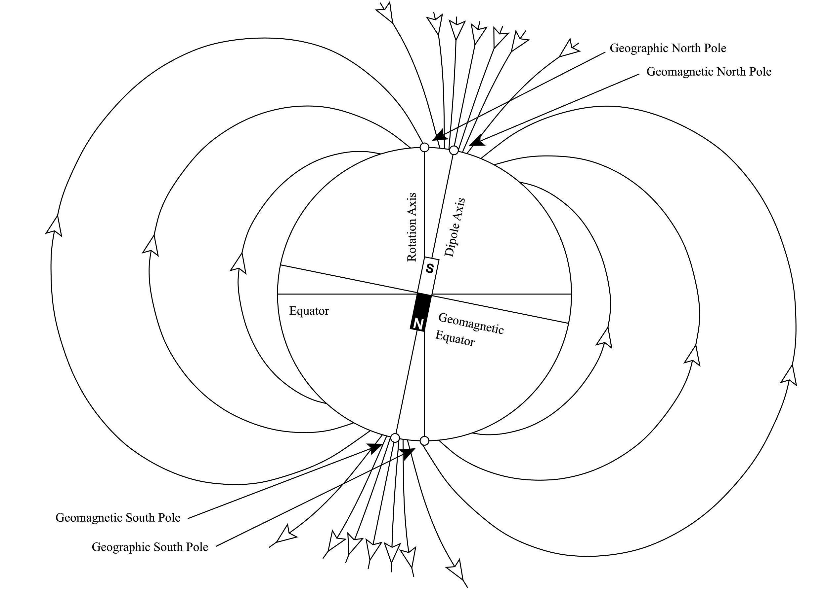

Figure 2.1: The differentiation between magnetic north and true north.

## Kalman Filter

### Introduction

The Kalman Filter is an estimation algorithm that is popularly used in navigation systems, target tracking and terrain navigation and is often considered the most widely used prediction algorithm. The Kalman Filter can be considered a mostly simple algorithm and therefore it does not have a large computational cost associated with it (Norsuzila Ya’acob et al., 1989). The Kalman filter is named after Hungarian-born Professor and engineer, Rudolf E. Kálmán, who first published his paper describing the recursive algorithm in 1960. The problem that Kálmán set out to solve was to linearly filter discrete data. In real world situations there is often an uncertainty when trying to measure data from the situation, measurement noise. Furthermore, the situations rarely match exactly that of the dynamic model that has been created. This is due to most dynamic models making simplifying assumptions. This error between model and reality is called process noise. Due to these noises in either combination or individually, the estimations that any algorithm could calculate would be incorrect. The Kalman Filter takes this measurement noise and process noise into consideration when producing its estimates (Becker, 2022).

### Algorithm

™

# Content chapter

Unless the chapter heading already makes it clear, an introductory paragraph that explains how this chapter contributes to the objectives of the report/project

## Heading level 2

### Heading level 3

#### Deepest heading, only if you cannot do without it

"Text 1" is for normal paragraphs. A blank line is automatically created before each paragraph.

1. "Text 1 Items" for a list that is not automatically numbered.

2. List that is not automatically numbered.

3. List that is not automatically numbered.

"Text 2" is for a paragraph that fits under "Text 1 items".

Waffle waffle

* "Text 1 bullet" for a bulleted list;
* Bullet list item 2;
* "Text 2 bullet" for sub-points
* "Text 2 bullet" for sub-points
* Bullet list item 3.

"Text 2" also fits under "Text 1 bullet".

Table 1: Acceptable page layouts (manually set "keep with next" in paragraph style for tables)

|  |  |  |
| --- | --- | --- |
| Paper | Margins | |
|  | Left/Right [mm] | Top/Bottom [mm] |
| A4 |  |  |
| A5 |  |  |

An equation must read like part of the text. Some or other strange parameter is given by the following expression (note the full stop after the equation to indicate the end of the sentence):

$A/b=x^{2}/{\left(u+v\right)}^{0.5}$. (1)

In other cases the equation is in the middle of the sentence. Then the paragraph following the equation should start with a small letter. Another strange parameter is given by

$A/b=x^{2}/{\left(u+v\right)}^{0.5}$, (2)

where *y* represents a physical property.

Symbols that represent values of properties should be printed in italics, but SI units and names of functions (e.g. sin, cos and tan) must not be printed in italics. There must be a hard space between a number and its unit, e.g. 120 km. This type of space can be created using "Crtl-Shift-Spacebar".

Create sketches and diagrams in PowerPoint or Visio. Then copy the figure and select "Paste special" to insert it as "Picture (enhanced metafile)". The paragraph containing the figure should use the "Figure" style. If you type "Enter" in the "Figure" style, the next style is automatically "Caption".

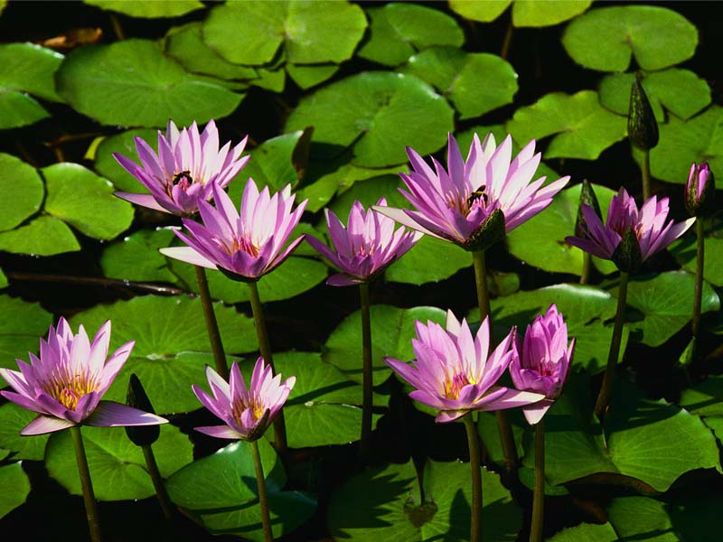

Figure 1: Water plants

# Conclusions

H

# References

Pompies, P, 1652, *My experiences on the Drommedaris*, 1st ed, Van Riebeeck Publishers, Cape Town.

Heading for this appendix

Bla bla

Note that for appendix headings use styles "Heading 7" and "Heading 8".

Note that all headings must have a title, just as a chapter has a heading

BlaBlaBla

SDCc

Dasqw